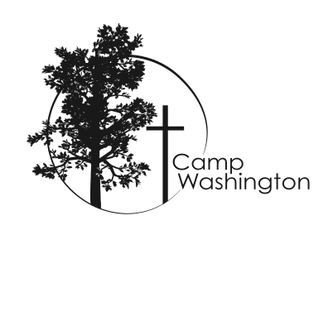
Camp Washington- Episcopal Church in Connecticut (ECCT)
Job Description

Job Title: Summer Camp Program Director
Reports to: Executive Director
Date Posted: November 2018
Dates of Employment: Part-time Seasonal (March- August)

Employer Overview: Camp Washington is the camp and retreat center for the Episcopal Church in Connecticut. We are an inviting, diverse, accepting community that offers a safe place for reflection and renewal, education and training, that encourages creativity and a sense of adventure by exploring and experiencing God’s mission of restoration and reconciliation. From summer camp to retreats and diocesan events, Camp Washington is a year-round place for discipleship rooted in the beauty of God’s creation and love.

Position Summary: A leader in all aspects of the residential camp program responsible for furthering the goals of Camp Washington through active recruitment of staff and campers, program development, marketing and social platforms.

Key Responsibilities:
- Define camp goals and/or define and plan program to reflect camp goals with the Executive Director and the Board of Directors.
- In collaboration with the Executive Director design a staff structure, hire and put in place a diverse community of counselors and program staff to support the goals of the program, within the confines of the budget.
- Uphold State of Connecticut regulations and 5-year ACA Accreditation.
- With the Executive Director, develop and monitor the budget for camp operations.
- Prepare and conduct pre-camp and in-service staff trainings. Ensure all certifications and ratios are met.
- Ensure all staff are Safe Church trained and certified.
- Develop and oversee a culture of inclusivity, encouragement and kindness. A culture where all are welcome and encouraged in their personal journey of faith.
- Establish program goals that align with the overall program goals of Camp Washington, and God’s mission.
- Working with the Executive Director or designee to order or supervise the ordering of supplies, operating within camp budget.
- Set and supervise office procedure, opening and closing day procedures for staff and campers.
- Oversee the daily operation of summer camp- camper/staff supervision, program, parent needs, health care, and any other issues that may arise.
- Develop routines, schedules and procedures for camp operation.
- Assign staff activities and other responsibilities, including cabin assignments and cabin groups
- Supervise and evaluate, or supervise evaluations of all summer staff.
- Work with Assistant Director and/or Head Counselor to develop and implement the Counselor in Training program.
- Oversee and monitor crisis, risk management, and healthcare procedures, including emergency plans.
- Organize and/or approve trips out of camp for program, supplies and crisis management, monitoring vehicle use.
- Manage maintenance requests using current resources and identifying future needs.
- Monitor safety and all procedures as they pertain to the complete supervision of all campers and staff.
- Prepare an evaluation and summary of current season including inventories, staff evaluations, camper reports and recommendations for the following season, including accident reports, nurses log and health forms of all staff and campers at end of camping season.
- Work with Executive Director and his/her designee to develop marketing strategies for summer camp.
- Create and maintain content for social media.
- Develop and implement a robust Christian Formation curriculum.
- Conduct parish visits as agreed upon with Executive Director.
- Remain current with youth trends and create appropriate programming that well positions Camp Washington.
- In collaboration with the Executive Director, honor appropriate past traditions while helping us build new.

These are not the only duties to be performed. Some duties may be reassigned other duties may be assigned as required.

Qualifications:
- Lively faith in Jesus Christ, knowledge of the Episcopal Church and a commitment to serve all of the people and parishes of the Episcopal Church in Connecticut by professional conduct and personal example.
- Bachelor’s Degree in camp administration, recreation, or related field preferred
- Minimum age of 25
- 2-4 years supervisory and/or camp ministry experience

Essential Functions:

- Ability to meet State of Connecticut licensing and ACA Accreditation Standard requirements.
- Current CPR and first aid certifications.
- Ability to manage a staff of 30-40 people, comprised of young adults, students, clergy, and other professionals.
- Passion for youth camping, and being in the outdoor beauty of God’s creation
- Ability to communicate well, both verbally and written word with campers, parents, staff and others.
- Experience and excitement in leading, teaching, and encouraging young people. Ability to offer patience and flexibility in dealing with young people.

- Have visual and auditory ability to observe, evaluate, and respond to environmental and other hazards throughout the camp program.
- Familiar with, and open towards the practices and beliefs of the Episcopal Church.
- Have ability to physically observe all aspects of camp operation
- Possess the physical strength and endurance required to maintain constant supervision of camp staff and campers with minimal time off during camp operation.
- Camp Director will reside on the Camp Washington campus during camp season and other programs as decided by Executive Director.

To apply, send resume and cover letter to:

bgeissinger@episcopalct.org

or:
Bart Geissinger
Executive Director- Camp Washington
190 Kenyon Road
Lakeside, CT 06758
www.campwashington.org

